ACTIVITY REPORT
Attendance:
___8___ members
___3___ non-members
___4___ staff
_______ invited guests
Organizer : UTAR Yoga Society . __________
Activity Name : Yoga Free trial class 2025 NOV session___________
Date : 6 Nov 2025 (Thursday) & 13 Nov 2025 (Thursday)__
Time : 6:30 pm – 7:30 pm___________________________
Venue : Performing Arts Studio (KB111 & KB112), Sungai___
Long Campus.

Reported by:

____________ _____SECRETARY_______ _7 December 2025__
(Susie)LIM SAIKEAT Designation Date

DESCRIPTION OF THE ACTIVITY
- Executive Summary
The Yoga Free Trial Classes 2025 – November Session were organized by UTAR Yoga Society as a wellness-focused, introductory multi-level yoga activity for UTAR students, especially with particular emphasis on October/November 2025 intake freshmen.

The overall atmosphere was relaxed and friendly, with a good response from freshmen and some ordinary members choosing to join or re-engage with the club after the sessions. The main achievement was providing free access to yoga using mats supplied by society, giving non-members a safe opportunity to experience yoga, supporting student wellbeing and stress relief, and cultivating interest for future membership and regular classes.

Session | Date | Time | Estimated Registered | Estimated Attended | Remarks
1 | 6 Nov 2025 (Thu) | 6:30–7:30 pm | ~8 | ~6 | Smaller but engaged group
2 | 13 Nov 2025 (Thu) | 6:30–7:30 pm | >10 | ~14 | Higher turnout; mix of new and existing faces
Across both sessions, there were a few new registered members (approx. 2–5) and additional participants whose interest was cultivated for future activities. Most participants were not complete beginners, but several had not practiced yoga for a long time and used this event to restart.

- Outcome
2.1 Activity progress for Both sessions flow:
1. Arrival and mat arrangement
2. Brief introduction and safety reminder
3. Gentle warm-up and joint mobilization
4. Multi-level yoga practice (standing, seated and simple balancing postures)
5. Cool-down, light stretching and simple breathing/relaxation
6. Closing reflection and sharing about future classes
Feedback form participance:
- The instructor engaged participants by asking about their experience of multi-level yoga, feelings of relaxation, and interest in other types of yoga or refresher sessions.
- Participants reported benefits such as muscle and back tension release and a sense of distress after class.

2.2 Outcome of the activity
Indicative outcomes:
- New registered members from the activity: approximately 2–5.
- Participants who expressed interest in future yoga classes or membership
- Several participants noted back pain relief and muscle distress and expressed appreciation for the free opportunity to join.

Overall, the activity contributed positively to the campus wellbeing environment and provided a concrete platform for membership drive and community building for UTAR Yoga Society.
New committee member
LIM SAI KEAT, 2504365, Secretary, Y1T1, susie.limsk2025@1utar.my

- Conclusion
Overall, the event can be rated meeting expectations, as it successfully provided a free and accessible stress-relief activity after class, attracted a positive response from freshmen and returning members, and created a relaxed, friendly atmosphere where participants interacted well with both the instructor and the committee. Many participants reported physical benefits such as relaxation, backpain relief and muscle tension release, indicating that the wellbeing objective was met. However, the number of new members recruited was lower than hoped for a short semester, the multi-level class format proved challenging for some participants, and the venue felt slightly crowded at higher turnout, suggesting the need for clearer level segmentation and better pre-registration control in future. Moving forward, the society plans to continue promoting yoga as a casual weekly activity open to all UTAR students, maintaining a clear focus on wellness and stress relief rather than income.

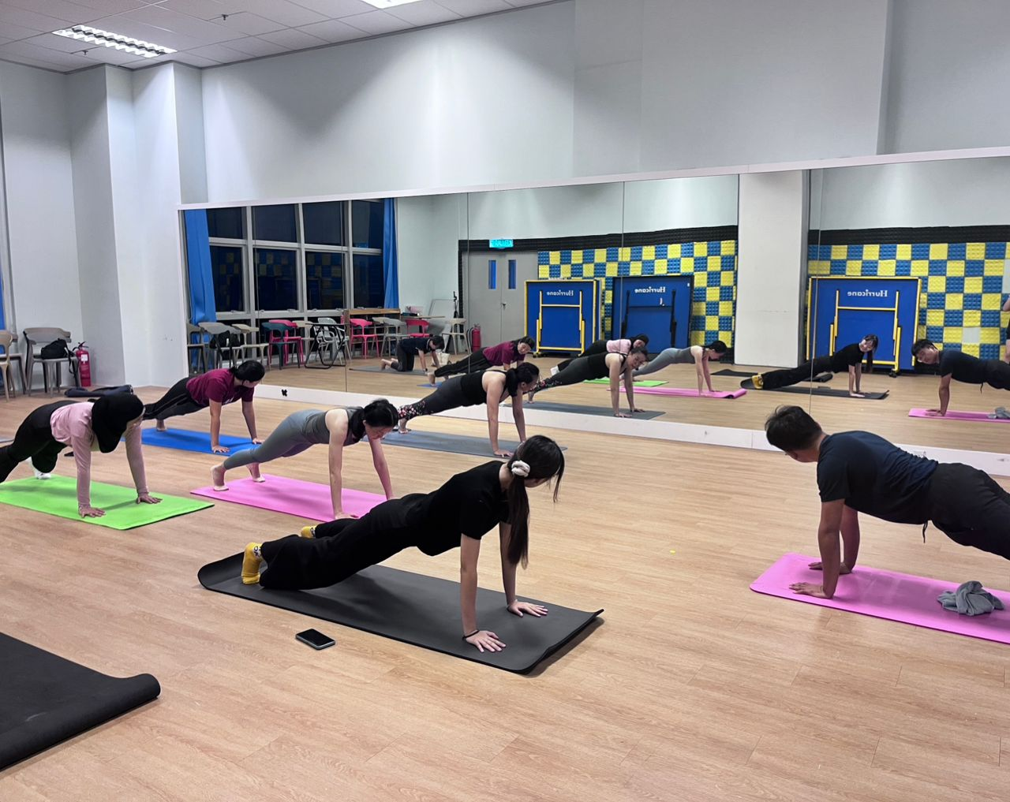

6 November 2025 6:50PM – Free trial class
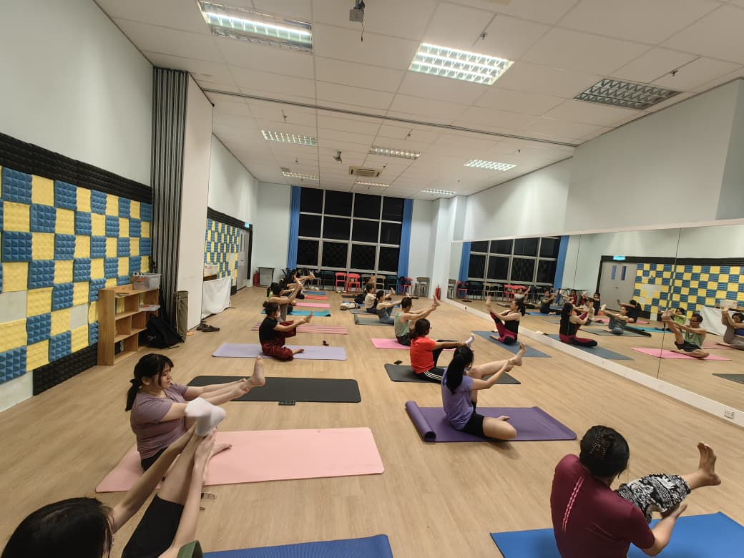
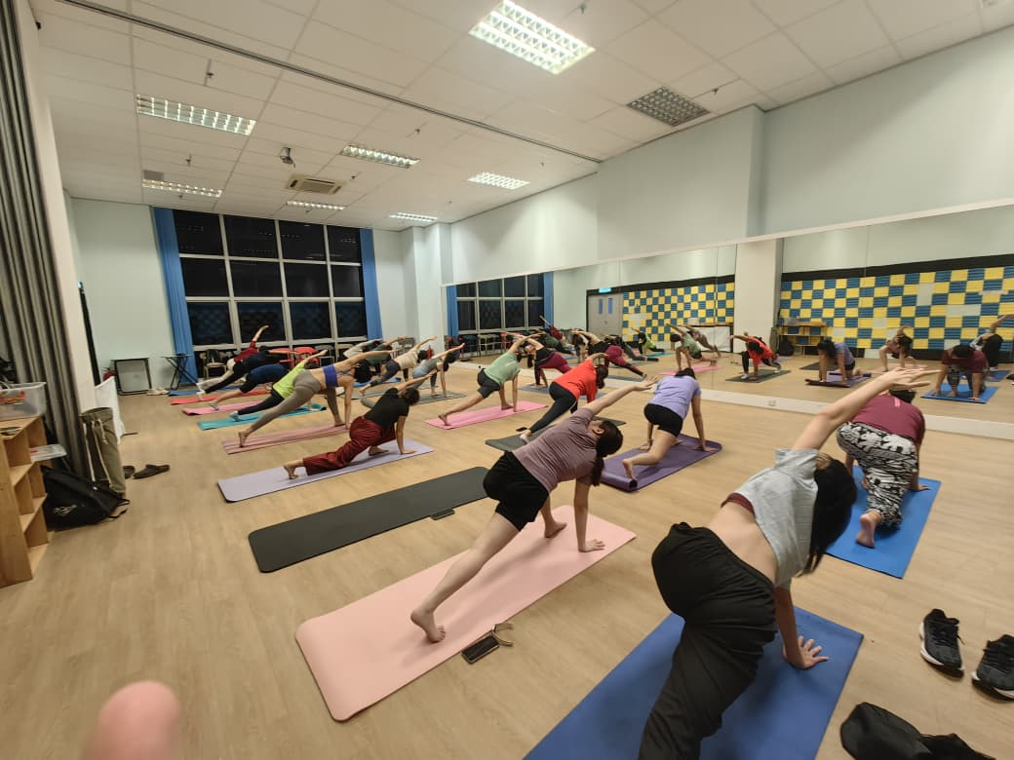

13 November 2025 6:50PM – Free trial class

